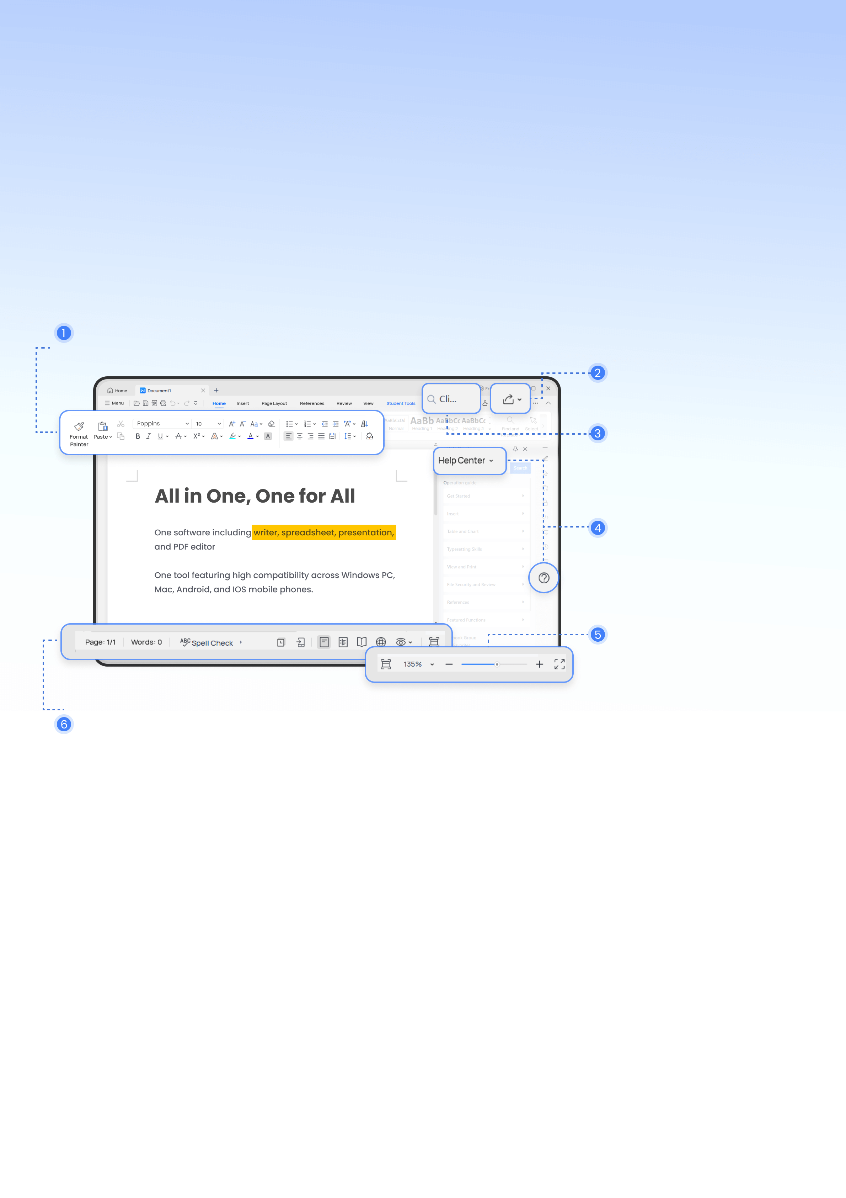

WPS Office®

Welcome to WPS Office - Writer

WPS Office is a lightweight, feature-rich comprehensive office suite with high compatibility. As a handy and professional office software, WPS Office allows you to edit files in Writer, Presentation, Spreadsheet, and PDF to improve your work efficiency.

Switch tabs to find different commands to process your document.

Share your documents with others.

Find all of Writer's commands.

Search the Help center for answers when you get stuck.

Quickly switch views and adjust the scale of the page display.

Count the number of words and pages in your document in real time.

WPS AI+Writer

WPS AI can help you create and enhance your inspiration in writing stuff. You can use WPS AI to help you write and understand your Word document.



WPS AI, fully embedded with ChatGPT capabilities, is coming soon. WPS Pro members have the opportunity to secure seats for internal testing and enjoy a special discount.

to help you write and understand your Word document

WPS AI-generated content

Just @AI, input a prompt and it will instantly generate text content in a professional format, such as brainstorming, to-do lists, working emails, social media posts, and more. The possibilities are endless.

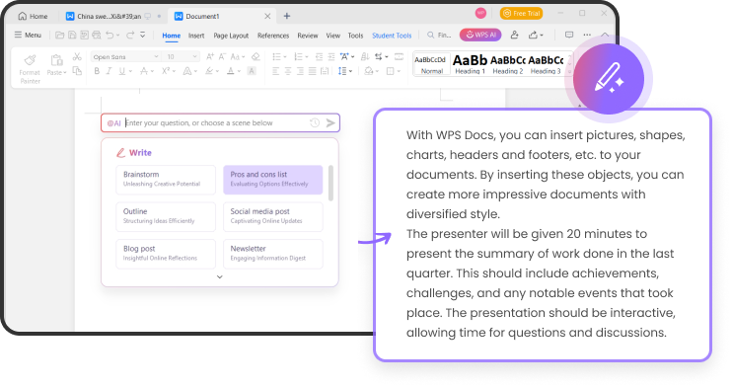

WPS AI-based content rewriting

If you already have your text and content. WPS AI can also help you improve it. Whether you need to make it shorter, longer, or change format, I've got you covered.

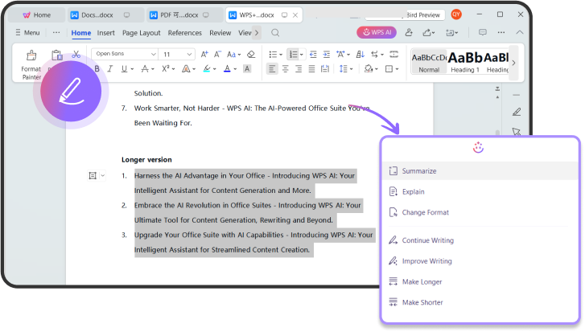

For all your document process needs

Restrict Editing

Sometimes at work, you may need to send documents to colleagues but want to prevent unauthorized changes by others.

Click on Review > Restrict Editing to set permissions for editing, reading, commenting, and other actions to enhance document security.

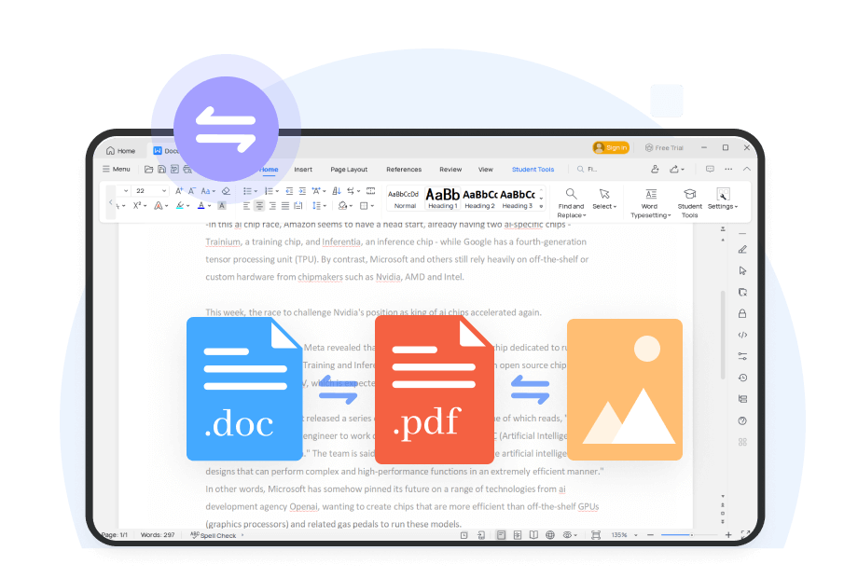

Co-Edit with Others

Share your work with others through links, QR codes, emails, and more. Everyone can simultaneously edit the same document, enabling seamless collaboration.



Format Conversion

Easily convert Word to PDF, PDF to Word, PNG, JPG, TXT, and more.

Effortlessly batch convert multiple files.

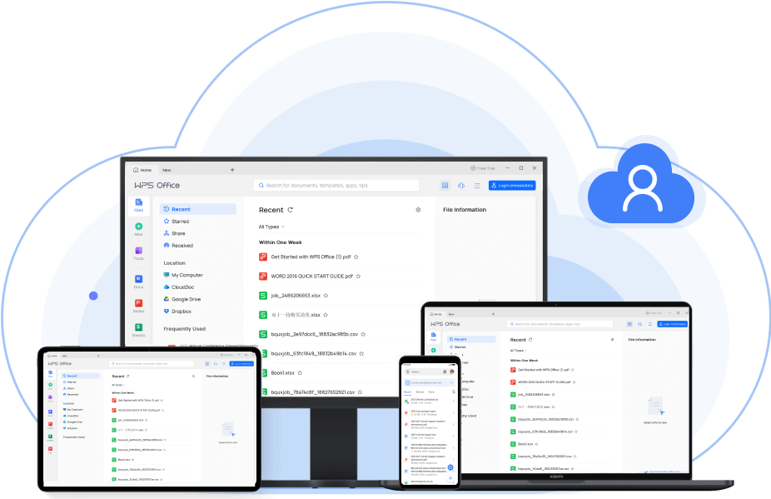

Editing and typesetting

Find and Replace

Use the Find and Replace function to quickly modify text in your documents, enhancing productivity. You can also search for specific formats to meet complex requirements.  
Click on Home > Find and Replace, with the shortcut key being Ctrl+F.

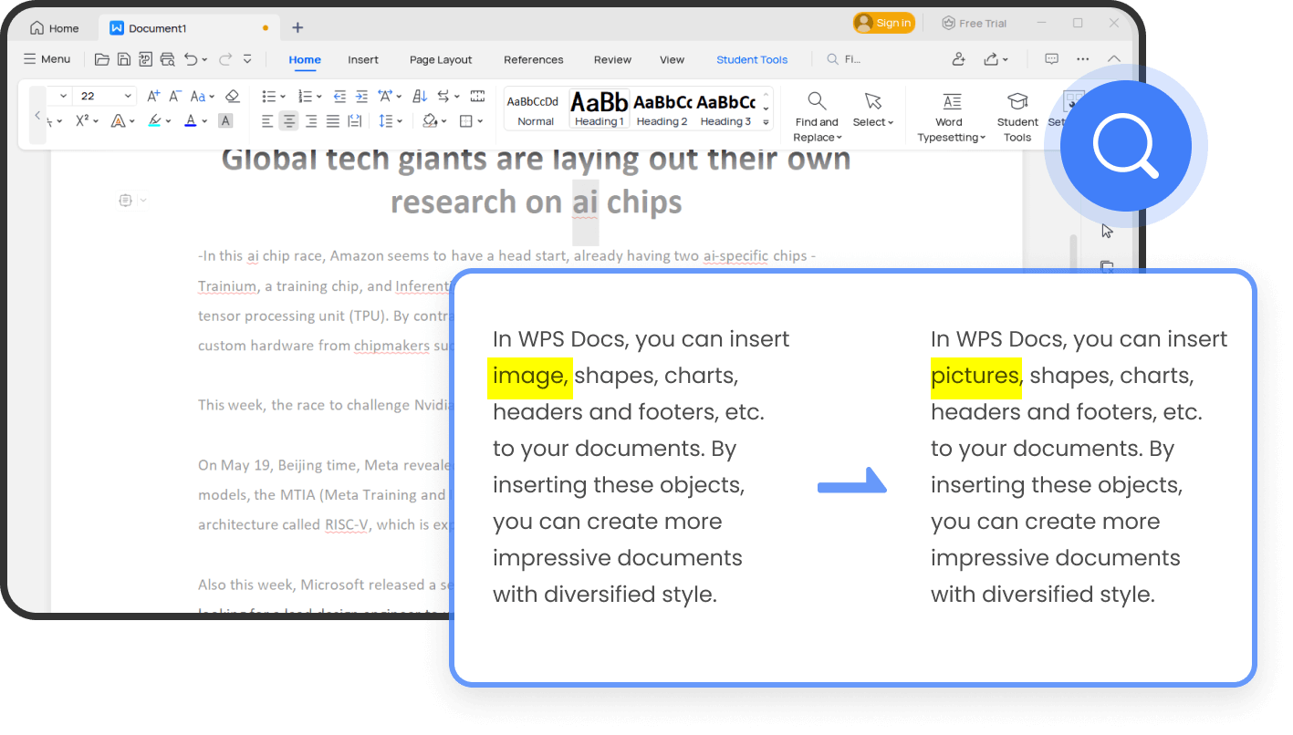

Efficient Word Typesetting

Using WPS saves time on document layout and leaves more room for creativity.   
Click on Home > Word Typesetting. With just one click, you can quickly adjust the document format and bulk delete document content such as blank pages, separators, text formatting, and objects.

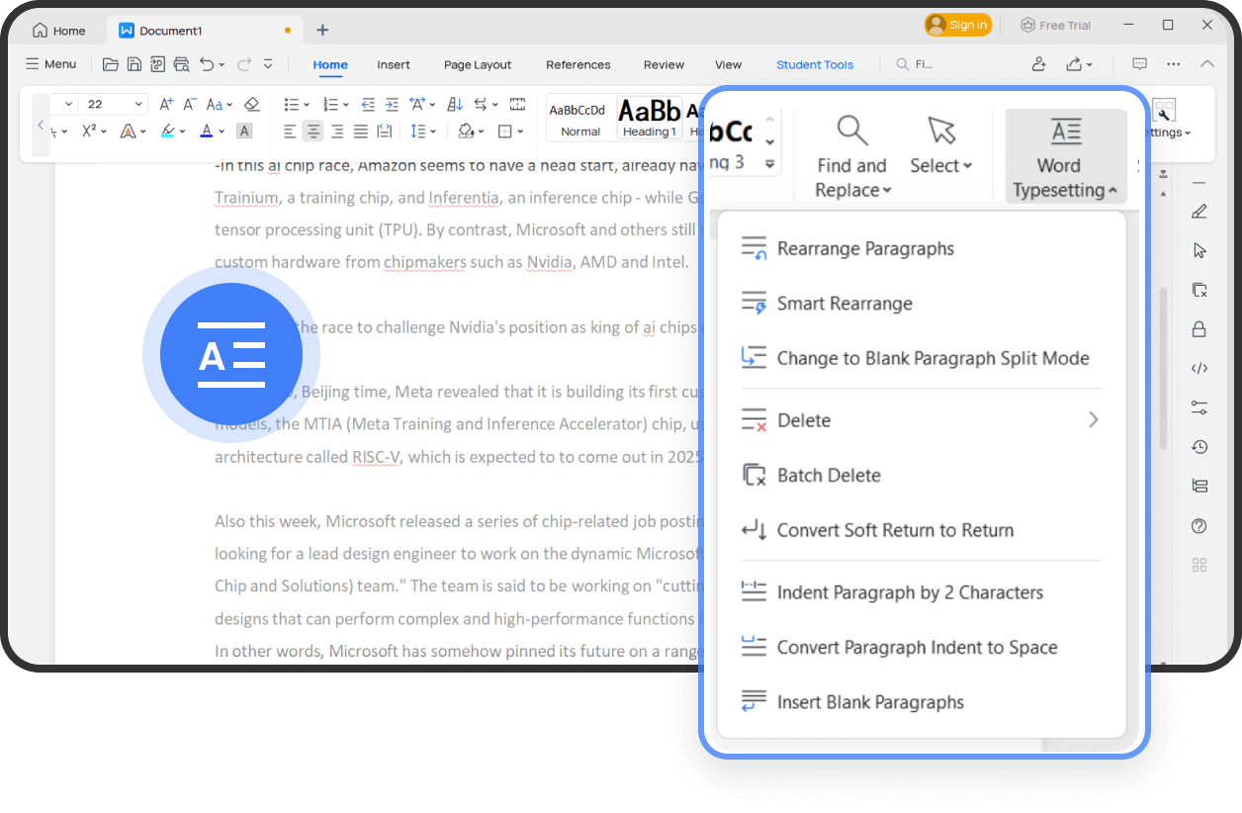

Spell Check

Finish and submit documents faster while ensuring they are free of spelling mistakes and grammatical errors.   
Click on Review > Spell Check to receive suggestions for corrections. This feature supports multiple languages.



Track Changes

Click on Review > Track Changes to assist the original author in identifying changes made during document editing.   
You can filter changes based on the date range or reviser, allowing you to focus on viewing revision records from specific individuals or time periods.   
Additionally, you can easily switch between the per-revision and post-revision states with a single click, facilitating easy comparison of changes.



More Popular features

|  |  |
| --- | --- |
| C:/Users/kingsoft/Desktop/wRITER/WRITER (6).pngWRITER (6) | Table of Contents  The Table of Contents can automatically identify the article chapters and title levels, generating the table of contents in just one second. |
| C:\Users\kingsoft\Desktop\wRITER\WRITER (2).pngWRITER (2) | Mail Merge  It enables you to batch generate and edit multiple documents, such as emails, invitations, greeting cards, pay slips, and more. Say goodbye to repetitive document editing. |
| C:\Users\kingsoft\Desktop\wRITER\WRITER (3).pngWRITER (3) | Table Tools  You can create tables directly in Writer without the need to create a new document. We provide a comprehensive table toolbox for beautification, formulas, sorting, and more. |
| C:\Users\kingsoft\Desktop\wRITER\WRITER (4).pngWRITER (4) | File Collection  With WPS File Collection, you can efficiently manage file sharing among team members. Collected files are automatically aggregated into a shared folder, allowing you to view, edit, and delete them at any time. |
| C:\Users\kingsoft\Desktop\wRITER\WRITER (5).pngWRITER (5) | Merge & Split  WPS Writer supports splitting or merging files, and you can customize the number of file splits. It provides an easier way to manage your documents. |
| C:\Users\kingsoft\Desktop\wRITER\WRITER (13).pngWRITER (13) | Eye Protection Mode  By adjusting the screen's color temperature and brightness, you can reduce blue light radiation, minimize eye fatigue, and ensure optimal vision during work and study. |



# Install free WPS Office to enjoy the same benefits on Android & ios!

# Free ALL-IN-ONE Office Suite

Install free WPS Office to enjoy the same benefits on Android & ios!